Jeremy Scheuerman

Dr. Wang

Cosc 120

Lab 7 Arrays

7.1

1.

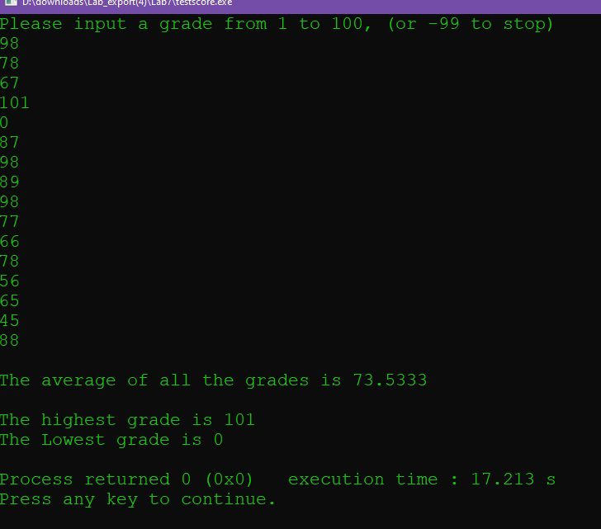

2.

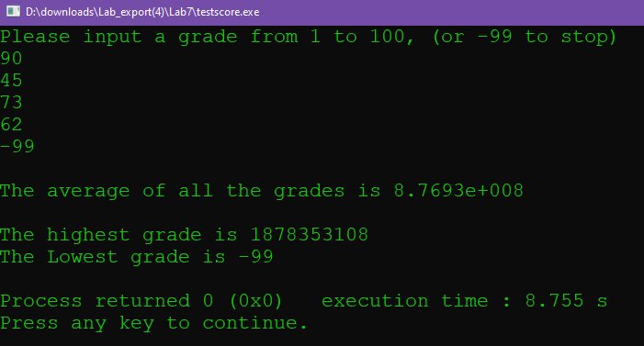

3.

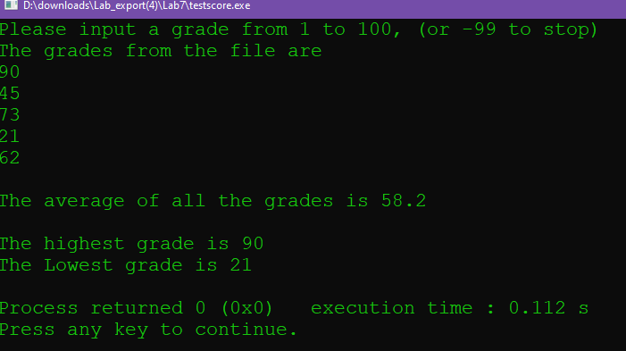

(note a misspelling caused me errors here)

Source Code

// This program will read in a group of test scores (positive integers from 1 to 100)

// from the keyboard and then calculate and output the average score

// as well as the highest and lowest score. There will be a maximum of 100 scores.

// PLACE YOUR NAME HERE

#include <iostream>

#include <fstream>

#include <string>

using namespace std;

typedef int GradeType[100]; // declares a new data type:

// an integer array of 100 elements

float findAverage(const GradeType, int); // finds average of all grades

int findHighest(const GradeType, int); // finds highest of all grades

int findLowest(const GradeType, int); // finds lowest of all grades

int main()

{

GradeType grades; // the array holding the grades.

int numberOfGrades; // the number of grades read.

int pos; // index to the array.

float avgOfGrades; // contains the average of the grades.

int highestGrade; // contains the highest grade.

int lowestGrade; // contains the lowest grade.

ifstream dataIn;

dataIn.open("gradefile.txt");

numberOfGrades = 5; // Fill blank with appropriate identifier

// Read in the values into the array

pos = 0;

cout << "Please input a grade from 1 to 100, (or -99 to stop)" << endl;

cout<<"The grades from the file are"<<endl;

//cin >> grades[pos];

while (grades[pos] != -99)

{

// Fill in the code to read the grades

dataIn>>grades[pos];

cout<<grades[pos]<<endl;

pos++;

if (pos==numberOfGrades)

{

break;

}

}

// call to the function to find average

avgOfGrades = findAverage(grades, numberOfGrades);

cout << endl << "The average of all the grades is " << avgOfGrades << endl;

highestGrade= findHighest(grades,numberOfGrades);

// Fill in the call to the function that calculates highest grade

cout << endl << "The highest grade is " << highestGrade << endl;

// Fill in the call to the function that calculates lowest grade

// Fill in code to write the lowest to the screen

lowestGrade= findLowest(grades,numberOfGrades);

cout<<"The Lowest grade is "<<lowestGrade<<endl;

return 0;

}

//********************************************************************************

// findAverage

//

// task: This function receives an array of integers and its size.

// It finds and returns the average of the numbers in the array

// data in: array of floating point numbers

// data returned: average of the numbers in the array

//

//********************************************************************************

float findAverage(const GradeType array, int size)

{

float sum = 0; // holds the sum of all the numbers

for (int pos = 0; pos < size; pos++)

sum = sum + array[pos];

return (sum / size); // returns the average

}

int findHighest(const GradeType array, int size)

{

int highest=0;

for(int i=0; i<size; i++)

{

if (array[i]>highest)

{

highest=array[i];

//reassign

}

// Fill in the code for this function

}

return highest;

}

//****************************************************************************

// findLowest

//

// task: This function receives an array of integers and its size.

// It finds and returns the lowest value of the numbers in

// the array

// data in: array of floating point numbers

// data returned: lowest value of the numbers in the array

//

//****************************************************************************

int findLowest(const GradeType array, int size)

{

int lowest=100;

for(int i=0; i<size; i++)

{

if (array[i]<lowest)

{

lowest=array[i];

//reassign

}

// Fill in the code for this function

}

return lowest;

}

7.2

1.

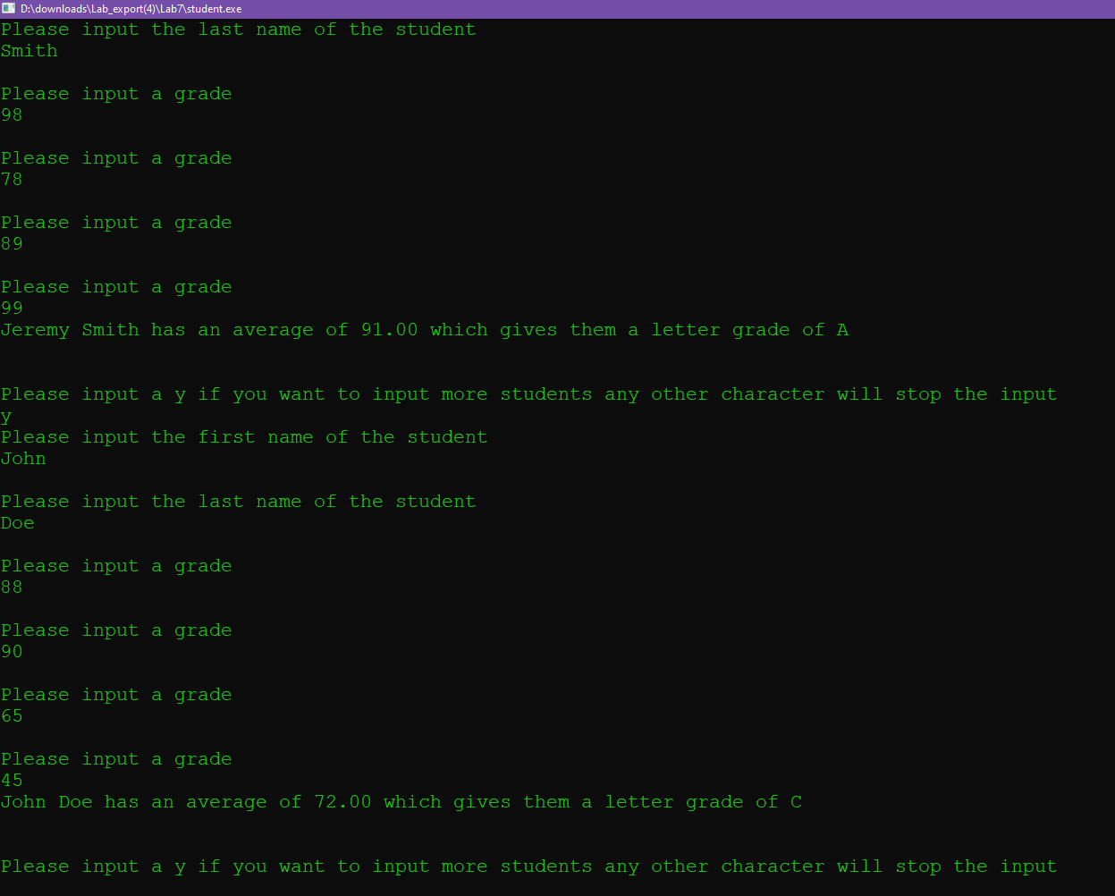

Source Code

// This program will input an undetermined number of student names

// This program will input an undetermined number of student names

// and a number of grades for each student. The number of grades is

// given by the user. The grades are stored in an array.

// Two functions are called for each student.

// One function will give the numeric average of their grades.

// The other function will give a letter grade to that average.

// Grades are assigned on a 10 point spread.

// 90-100 A 80-89 B 70-79 C 60-69 D Below 60 F

// PLACE YOUR NAME HERE

#include <iostream>

#include <iomanip>

using namespace std;

const int MAXGRADE = 25; // maximum number of grades per student

const int MAXCHAR = 30; // maximum characters used in a name

typedef char StringType30[MAXCHAR + 1]; // character array data type for names

// having 30 characters or less.

typedef float GradeType[MAXGRADE]; // one dimensional integer array data type

float findGradeAvg(GradeType, int); // finds grade average by taking array of

// grades and number of grades as parameters

char findLetterGrade(float); // finds letter grade from average given

// to it as a parameter

int main()

{

StringType30 firstname, lastname; // two arrays of characters defined

int numOfGrades; // holds the number of grades

GradeType grades; // grades defined as a one dimensional array

float average; // holds the average of a student's grade

char moreInput; // determines if there is more input

char letter;

cout << setprecision(2) << fixed << showpoint;

// Input the number of grades for each student

cout << "Please input the number of grades each student will receive." << endl

<< "This must be a number between 1 and " << MAXGRADE << " inclusive"

<< endl;

cin >> numOfGrades;

while (numOfGrades > MAXGRADE || numOfGrades < 1)

{

cout << "Please input the number of grades for each student." << endl

<< "This must be a number between 1 and " << MAXGRADE

<< " inclusive\n";

cin >> numOfGrades;

}

// Input names and grades for each student

cout << "Please input a y if you want to input more students"

<< " any other character will stop the input" << endl;

cin >> moreInput;

while (moreInput == 'y' || moreInput == 'Y')

{

cout << "Please input the first name of the student" << endl;

cin >> firstname;

cout << endl << "Please input the last name of the student" << endl;

cin >> lastname;

for (int count = 0; count < numOfGrades; count++)

{

cout << endl << "Please input a grade" << endl;

cin>>grades[count];

// Fill in the input statement to place grade in the array

}

cout << firstname << " " << lastname << " has an average of ";

// Fill in code to get and print average of student to screen

average=findGradeAvg(grades,numOfGrades);

cout<<average;

// Fill in call to get and print letter grade of student to screen

letter=findLetterGrade(average);

cout<<" which gives them a letter grade of "<<letter;

cout << endl << endl << endl;

cout << "Please input a y if you want to input more students"

<< " any other character will stop the input" << endl;

cin >> moreInput;

}

return 0;

}

//***********************************************************************

// findGradeAvg

//

// task: This function finds the average of the

// numbers stored in an array.

//

// data in: an array of integer numbers

// data returned: the average of all numbers in the array

//

//***********************************************************************

float findGradeAvg(GradeType array, int numGrades)

{

int total_grades=0;

float avg_grades=0;

for (int i=0; i<numGrades; i++)

{

total_grades+=array[i];

//add all to total

}

avg_grades=total_grades/numGrades;

return avg_grades;

// Fill in the code for this function

}

//***********************************************************************

// findLetterGrade

//

// task: This function finds the letter grade for the number

// passed to it by the calling function

//

// data in: a floating point number

// data returned: the grade (based on a 10 point spread) based on the

// number passed to the function

//

//***********************************************************************

char findLetterGrade(float numGrade)

{

char letterGrade;

if (numGrade>=90)

{

letterGrade='A';

}

else if((numGrade>=80)&&(numGrade<90))

{

letterGrade='B';

}

else if((numGrade>=70)&&(numGrade<80))

{

letterGrade='C';

}

else if((numGrade>=60)&&(numGrade<70))

{

letterGrade='D';

}

else if(numGrade<60)

{

letterGrade='F';

}

else

{

letterGrade='W';

}

// Fill in the code for this function

return letterGrade;

}

7.3

1.

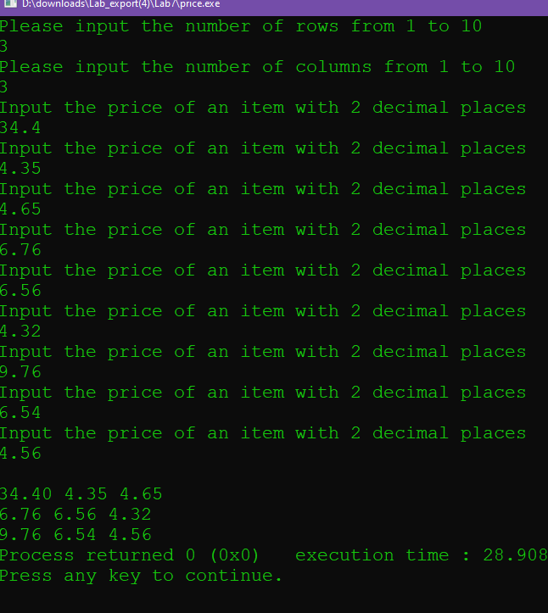

2.

The getPrices array values are pass by reference because of the pointer.

The printPrices are pass by value because they do not use a pointer.

3-4

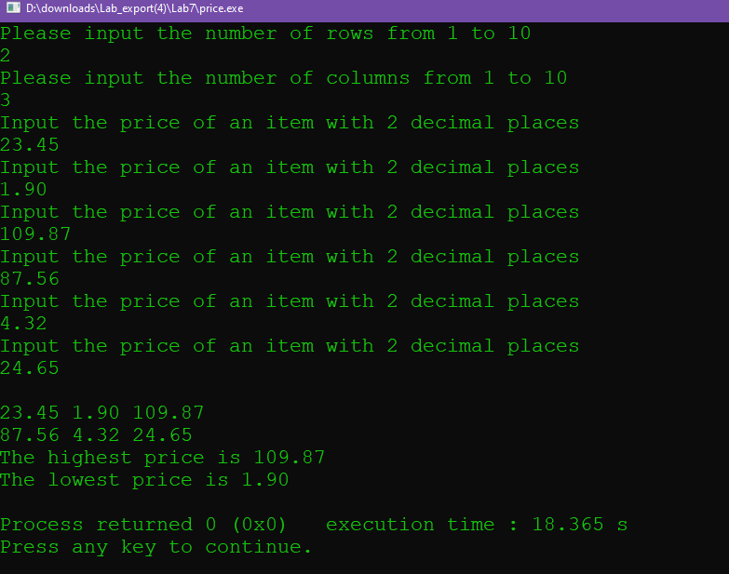

5.

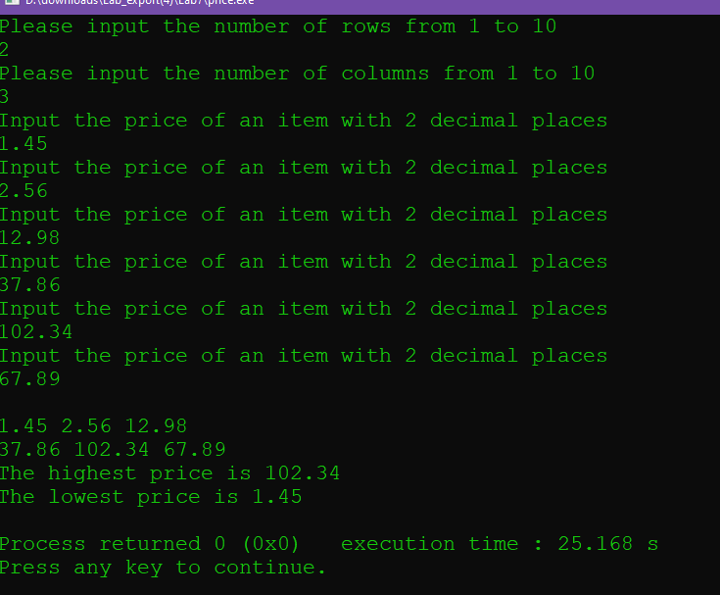

Source Code 1

// This program will read in prices and store them into a two-dimensional array.

// It will print those prices in a table form.

// PLACE YOUR NAME HERE

#include <iostream>

#include <iomanip>

using namespace std;

const int MAXROWS = 10;

const int MAXCOLS = 10;

typedef float PriceType[MAXROWS][MAXCOLS]; // creates a new data type

// of a 2D array of floats

void getPrices(PriceType, int&, int&); // gets the prices into the array

void printPrices(PriceType, int, int); // prints data as a table

float findHighestPrice(PriceType table, int numOfRows, int numOfCols);

float findLowestPrice(PriceType table, int numOfRows, int numOfCols);

int main()

{

int rowsUsed; // holds the number of rows used

int colsUsed; // holds the number of columns used

PriceType priceTable; // a 2D array holding the prices

getPrices(priceTable, rowsUsed, colsUsed); // calls getPrices to fill the array

printPrices(priceTable, rowsUsed, colsUsed); // calls printPrices to display array

cout<<"The highest price is "<<findHighestPrice( priceTable,rowsUsed,colsUsed)<<endl;

cout<<"The lowest price is "<<findLowestPrice( priceTable,rowsUsed,colsUsed)<<endl;

return 0;

}

float findHighestPrice(PriceType table, int numOfRows, int numOfCols)

// This function returns the highest price in the array

{

float highestPrice;

highestPrice = table[0][0]; // make first element the highest price

for (int row = 0; row < numOfRows; row++)

for (int col = 0; col < numOfCols; col++)

if ( highestPrice < table[row][col] )

highestPrice = table[row][col];

return highestPrice;

}

float findLowestPrice(PriceType table, int numOfRows, int numOfCols)

// This function returns the highest price in the array

{

float lowestPrice;

lowestPrice = table[0][0]; // make first element the highest price

for (int row = 0; row < numOfRows; row++)

for (int col = 0; col < numOfCols; col++)

if (lowestPrice > table[row][col] )

lowestPrice = table[row][col];

return lowestPrice;

}

//*******************************************************************************

// getPrices

//

// task: This procedure asks the user to input the number of rows and

// columns. It then asks the user to input (rows * columns) number of

// prices. The data is placed in the array.

// data in: none

// data out: an array filled with numbers and the number of rows

// and columns used.

//

//*******************************************************************************

void getPrices(PriceType table, int& numOfRows, int& numOfCols)

{

cout << "Please input the number of rows from 1 to " << MAXROWS << endl;

cin >> numOfRows;

cout << "Please input the number of columns from 1 to " << MAXCOLS << endl;

cin >> numOfCols;

for (int row = 0; row < numOfRows; row++)

{

for (int col = 0; col < numOfCols; col++)

{

cout<<"Input the price of an item with 2 decimal places"<<endl;

cin>>table[row][col];

// Fill in the code to read and store the next value in the array

}

}

}

//***************************************************************************

// printPrices

//

// task: This procedure prints the table of prices

// data in: an array of floating point numbers and the number of rows

// and columns used.

// data out: none

//

//****************************************************************************

void printPrices(PriceType table, int numOfRows, int numOfCols)

{

cout << fixed << showpoint << setprecision(2);

for (int row = 0; row < numOfRows; row++)

{

cout<<endl;

for (int col = 0; col < numOfCols; col++)

{

cout<<table[row][col]<<" ";

// Fill in the code to print the table

}

}

cout<<endl;

}

6.

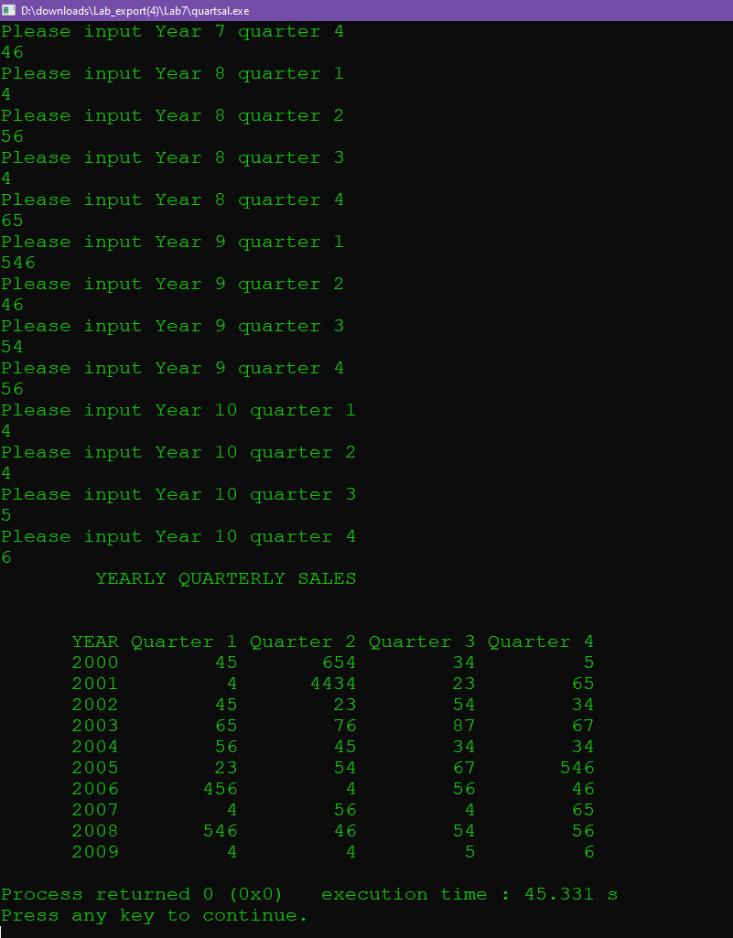

7.

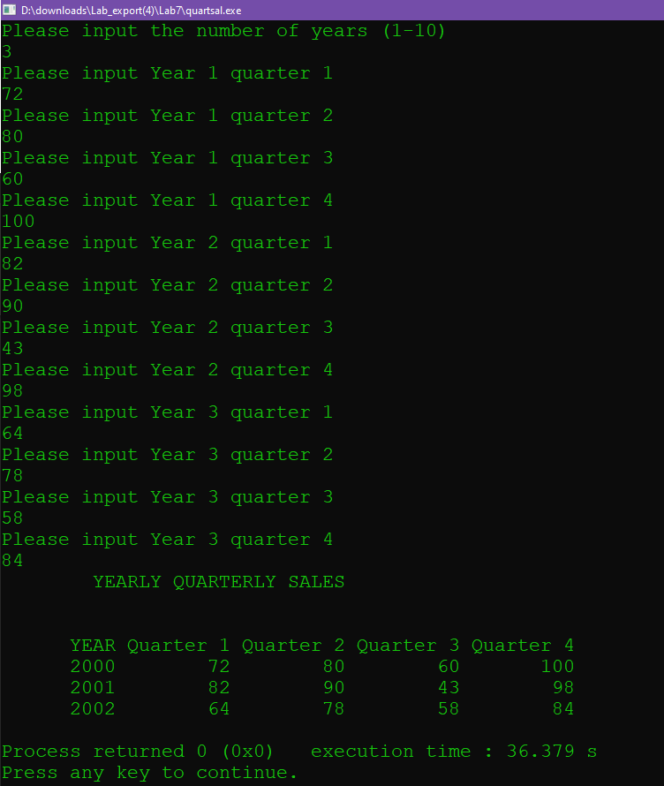Source Code

// This program will read in the quarterly sales transactions for a given number

// of years. It will print the year and transactions in a table format.

// It will calculate year and quarter total transactions.

// PLACE YOUR NAME HERE

#include <iostream>

#include <iomanip>

using namespace std;

const int MAXYEAR = 10;

const int MAXCOL = 5;

typedef int SalesType[MAXYEAR][MAXCOL]; // creates a new 2D integer data type

void getSales(SalesType, int&); // places sales figures into the array

void printSales(SalesType, int); // prints data as a table

void printTableHeading(); // prints table heading

int main()

{

int yearsUsed; // holds the number of years used

SalesType sales; // 2D array holding the sales transactions

getSales(sales, yearsUsed); // calls getSales to put data in array

printTableHeading(); // calls procedure to print the heading

printSales(sales, yearsUsed); // calls printSales to display table

return 0;

}

//*****************************************************************************

// printTableHeading

//

// task: This procedure prints the table heading

// data in: none

// data out: none

//

//*****************************************************************************

void printTableHeading()

{

cout << setw(30) << "YEARLY QUARTERLY SALES" << endl << endl << endl;

cout << setw(10) << "YEAR" << setw(10) << "Quarter 1"

<< setw(10) << "Quarter 2" << setw(10) << "Quarter 3"

<< setw(10) << "Quarter 4" << endl;

}

//*****************************************************************************

// getSales

//

// task: This procedure asks the user to input the number of years.

// For each of those years it asks the user to input the year

// (e.g. 2004), followed by the sales figures for each of the

// 4 quarters of that year. That data is placed in a 2D array

// data in: a 2D array of integers

// data out: the total number of years

//

//*****************************************************************************

void getSales(SalesType table, int& numOfYears)

{

cout << "Please input the number of years (1-" << MAXYEAR << ")" << endl;

cin >> numOfYears;

// Fill in the code to read and store the next value

int row=0;

int col=0;

for (row=0; row<numOfYears; row++)

{

for(col=1; col<5; col++)

{

cout<<"Please input Year "<<row+1<<" quarter "<< col<<endl;

cin>>table[row] [col];

//populate years on left hand side

}

}

}

//*****************************************************************************

// printSales

//

// task: This procedure prints out the information in the array

// data in: an array containing sales information

// data out: none

//

//*****************************************************************************

void printSales(SalesType table, int numOfYears)

{

// Fill in the code to print the table

int j=0;

//years counter

int year=2000;

for (int row=0; row<numOfYears; row++)

{

for(int col=0; col<5; col++)

{

if (col==0){

table[row][col]=2000+j;

cout<<setw(10)<<table[row][col];

//populate years on left hand side

}else{

cout<<setw(10)<<table[row] [col];

}

}

j++;

cout<<endl;

}

}

7.4

Option 1

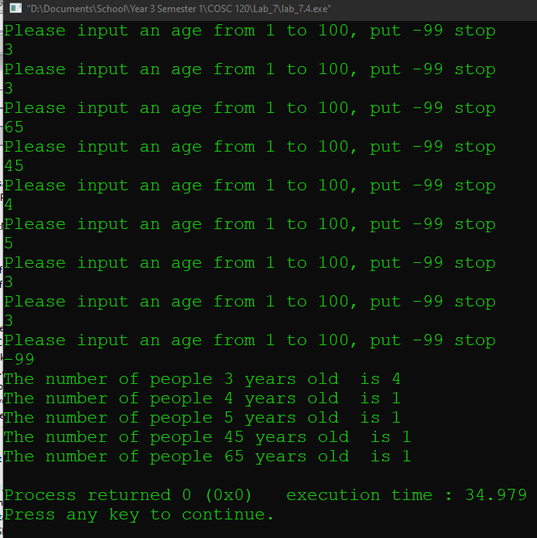

Source Code

#include <iostream>

using namespace std;

int main()

{

int arr[100];

for (int i=1; i<100; i++)

{

arr[i]=0;

//populate at 0

}

int age=0;

while (age!=-99)

{

cout<<"Please input an age from 1 to 100, put -99 stop"<<endl;

cin>>age;

arr[age]+=1;

}

for (int i=1; i<100; i++)

{

//populate at 0

if (arr[i]!=0)

{

cout<<"The number of people "<<i<<" years old "<<" is "<<arr[i]<<endl;

//print out amount of people

}

}

}

Option 2

#include <iostream>

using namespace std;

const int MAX_AMT=50;

typedef float temp[MAX_AMT];

int main()

{

int num=0;

double lowest=1000;

double highest=0;

double avg=0;

while (num>50)

{

cout<<"Please input the number of temperatures to be read"<<endl;

cin>>num;

}

temp temperature [num];

for (int i=0; i<num-1; i++)

{

cout<<"Input temperature "<<i<<":"<<endl;

cin>>temperature[i];

if (temperature[i]<lowest)

{

lowest=temperature[i];

//get lowest

}

if (temperature[i]>highest)

{

highest=temperature[i];

//get highest

}

avg+=temperature[i];

}

avg=avg/50;

//get average

cout<<"The average temperature is "<<avg;

cout<<"The highest temperature is "<<highest;

cout<<"The lowest temperature is "<<lowest;

//print

}

return 0;

}

Option 2

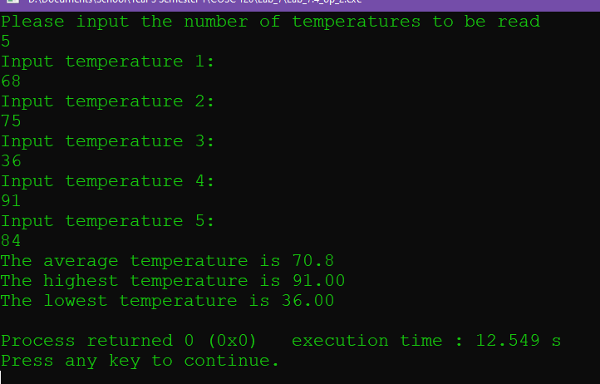

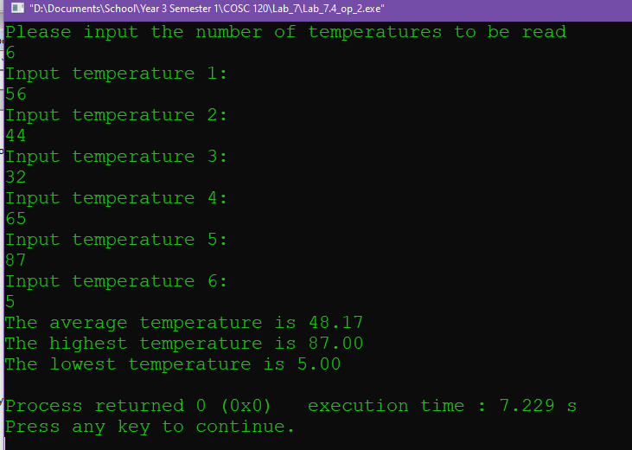

Source Code

#include <iostream>

#include <iomanip>

using namespace std;

const int MAX_AMT=50;

typedef float temp[MAX_AMT];

float get_average(temp temperature,int num);

float get_highest(temp temperature,int num);

float get_lowest(temp temperature,int num)

{

float lowest=1000;

for (int i=0; i<num; i++)

{

if (temperature[i]<lowest)

{

lowest=temperature[i];

//get lowest

}

}

return lowest;

}

float get_highest(temp temperature,int num)

{

float highest=0;

for (int i=0; i<num; i++)

{

if (temperature[i]>highest)

{

highest=temperature[i];

//get highest

}

}

return highest;

}

float get_average(temp temperature,int num)

{

float avg=0;

for (int i=0; i<num; i++)

{

avg+=temperature[i];

}

avg=avg/num;

return avg;

}

int main()

{

int num=51;

float avg=0;

float highest=0;

float lowest=0;

while (num>50)

{

cout<<"Please input the number of temperatures to be read"<<endl;

cin>>num;

}

temp temperature;

for (int i=0; i<num; i++)

{

cout<<"Input temperature "<<i+1<<":"<<endl;

cin>>temperature[i];

//assign

}

avg=get_average(temperature,num);

//get average

highest=get_highest(temperature,num);

//get highest

lowest=get_lowest(temperature,num);

//get lowest

cout<<"The average temperature is "<<fixed<<setprecision(2)<<avg<<endl;;

cout<<"The highest temperature is "<<fixed<<setprecision(2)<<highest<<endl;

cout<<"The lowest temperature is "<<fixed<<setprecision(2)<<lowest<<endl;

//print

return 0;

}

Option 3

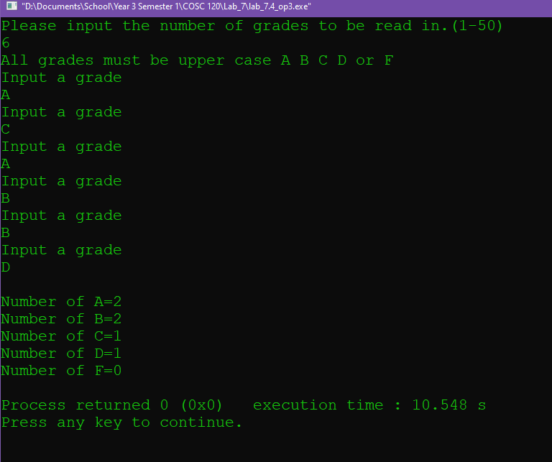

Source Code

#include <iostream>

using namespace std;

int number_grades(char grade_arr[],char letter,int num);

int number_grades(char grade_arr[],char letter,int num)

{

int amnt =0;

//return letter

for (int i=0; i<num; i++)

{

if (grade_arr[i]==letter)

{

amnt++;

//tally letters

}

}

return amnt;

}

int main()

{

int num=0;

int amnt_A=0;

int amnt_B=0;

int amnt_C=0;

int amnt_D=0;

int amnt_F=0;

//declare amounts

cout<<"Please input the number of grades to be read in.(1-50)"<<endl;

cin>>num;

char grades[num];

cout<<"All grades must be upper case A B C D or F"<<endl;

for (int i=0; i<num; i++)

{

cout<<"Input a grade"<<endl;

cin>>grades[i];

}

amnt_A=number_grades(grades,'A',num);

amnt_B=number_grades(grades,'B',num);

amnt_C=number_grades(grades,'C',num);

amnt_D=number_grades(grades,'D',num);

amnt_F=number_grades(grades,'F',num);

//get amnts

cout<<endl<<"Number of A="

<<amnt_A<<endl;

cout<<"Number of B="<<amnt_B<<endl;

cout<<"Number of C="<<amnt_C<<endl;

cout<<"Number of D="<<amnt_D<<endl;

cout<<"Number of F="<<amnt_F<<endl;

//output

return 0;

}